Chemistry 115 Name ____________key_______________
Quiz 2a
Dr. Cary Willard September 3, 2013

All work must be shown to receive credit. Use correct significant figures. $℃=\frac{℉-32}{1.8} , ℉=1.8℃+32, K=℃+273$

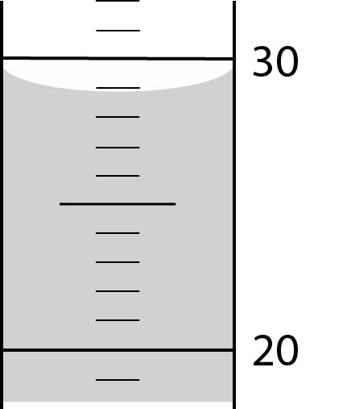
- (4 points) What is the volume of liquid in the graduated cylinder at the right? (The cylinder is calibrated in mL)

28.9 mL

- (6 points) Complete the following conversions
  - 38.6 cm to m

$$38.6 cm×\frac{1 m}{100 cm}=0.386 m$$

  - 73.2 kg to lb

$$73.2 kg×\frac{1000 g}{1 kg}×\frac{1 lb}{454 g}=161 lb$$

- (5 points) How many days would it take for a crepe myrtle tree to grow 5.00 cm in height if it grows 4.27 feet per year?

$$?days=5.00 cm×\frac{1in}{2.54 cm}×\frac{1 ft}{12 in}×\frac{1 yr}{4.27 ft}×\frac{365 days}{1 yr}=14.0 days$$

- (5 points) Make the following temperature conversions
  - 84ºF to ºC

$$℃=\frac{℉-32}{1.8}=\frac{84℉-32℉}{1.8℃/℉}=29℃$$

  - 52º C to K

$$K=℃+273=52℃+273=325 K$$

Chemistry 115 Name ____________key_______________
Quiz 2b
Dr. Cary Willard September 3, 2013

All work must be shown to receive credit. Use correct significant figures. $℃=\frac{℉-32}{1.8} , ℉=1.8℃+32, K=℃+273$

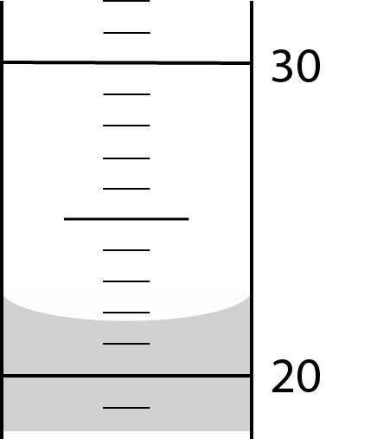
- (4 points) What is the volume of liquid in the graduated cylinder at the right? (The cylinder is calibrated in mL)

21.8 mL

- (6 points) Complete the following conversions
  - 95.4 cm to m

$$95.4 cm×\frac{1 m}{100 cm}=0.954 m$$

  - 73.2 kg to lb

$$62.4 kg×\frac{1000 g}{1 kg}×\frac{1 lb}{454 g}=137 lb$$

- (5 points) How many days would it take for a crepe myrtle tree to grow 8.00 cm in height if it grows 4.27 feet per year?

$$?days=8.00 cm×\frac{1in}{2.54 cm}×\frac{1 ft}{12 in}×\frac{1 yr}{4.27 ft}×\frac{365 days}{1 yr}=22.4 days$$

- (5 points) Make the following temperature conversions
  - 61ºF to ºC

$$℃=\frac{℉-32}{1.8}=\frac{61℉-32℉}{1.8℃/℉}=16℃$$

  - 88º C to K

$$K=℃+273=88℃+273=361 K$$

Chemistry 115 Name ____________key_______________
Quiz 2c
Dr. Cary Willard September 3, 2013

All work must be shown to receive credit. Use correct significant figures. $℃=\frac{℉-32}{1.8} , ℉=1.8℃+32, K=℃+273$

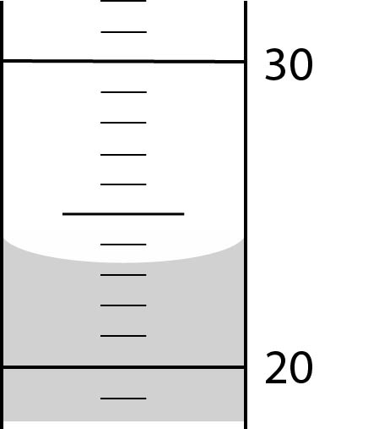
- (4 points) What is the volume of liquid in the graduated cylinder at the right? (The cylinder is calibrated in mL)

28.9 mL

- (6 points) Complete the following conversions
  - 0.571 kg to g

$$0.571 kg×\frac{1 kg}{1000 g}=571 g$$

  - 64.2 qt to L

$$64.2 qt×\frac{946 mL}{1 qt}×\frac{1 L}{1000 mL}=60.7 L$$

- (5 points) How many days would it take for a crepe myrtle tree to grow 5.00 cm in height if it grows 6.48 feet per year?

$$?days=5.00 cm×\frac{1in}{2.54 cm}×\frac{1 ft}{12 in}×\frac{1 yr}{6.48 ft}×\frac{365 days}{1 yr}=9.24 days$$

- (5 points) Make the following temperature conversions
  - 24ºC to ºF

$$℉=1.8℃+32=\left(1.8℉/℃\right)\left(24℃\right)+32℉=75℉$$

  - 63º C to K

$$K=℃+273=63℃+273=336 K$$

Chemistry 115 Name ____________key_______________
Quiz 2d
Dr. Cary Willard September 3, 2013

All work must be shown to receive credit. Use correct significant figures. $℃=\frac{℉-32}{1.8} , ℉=1.8℃+32, K=℃+273$

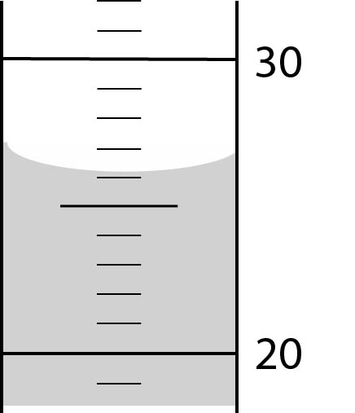
- (4 points) What is the volume of liquid in the graduated cylinder at the right? (The cylinder is calibrated in mL)

28.9 mL

- (6 points) Complete the following conversions
  - 0.672 kg to g

$$0.672 kg×\frac{1 kg}{1000 g}=672 g$$

  - 32.9 qt to L

$$32.9 qt×\frac{946 mL}{1 qt}×\frac{1 L}{1000 mL}=31.1 L$$

- (5 points) How many days would it take for a crepe myrtle tree to grow 8.00 cm in height if it grows 6.48 feet per year?

$$?days=8.00 cm×\frac{1in}{2.54 cm}×\frac{1 ft}{12 in}×\frac{1 yr}{6.48 ft}×\frac{365 days}{1 yr}=14.8 days$$

- (5 points) Make the following temperature conversions
  - 41ºC to ºF

$$℉=1.8℃+32=\left(1.8℉/℃\right)\left(41℃\right)+32℉=106℉$$

  - 29º C to K

$$K=℃+273=29℃+273=302 K$$

